An overview of the e-Controls application in CST2021

There are just several blank spaces to fill in such as:
- ID information where FLC should choose the number and project title (all other information will fill in automatically).
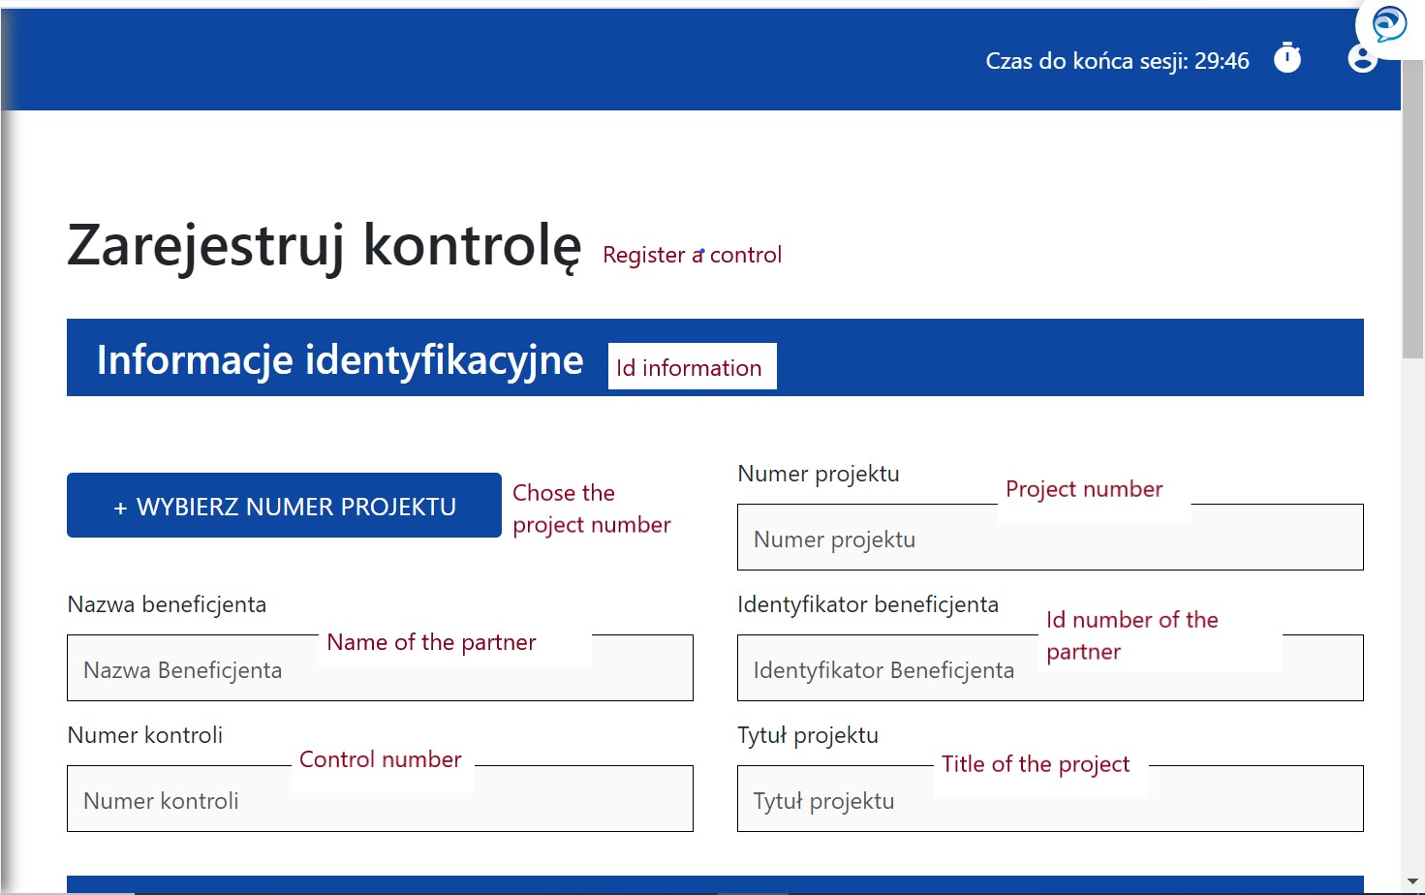
- Information about control such as: name of the partner, name of the body which performed the control, date and type of control (also a box to tick if it was an audit of operation, other control and if it was a public procurement control).
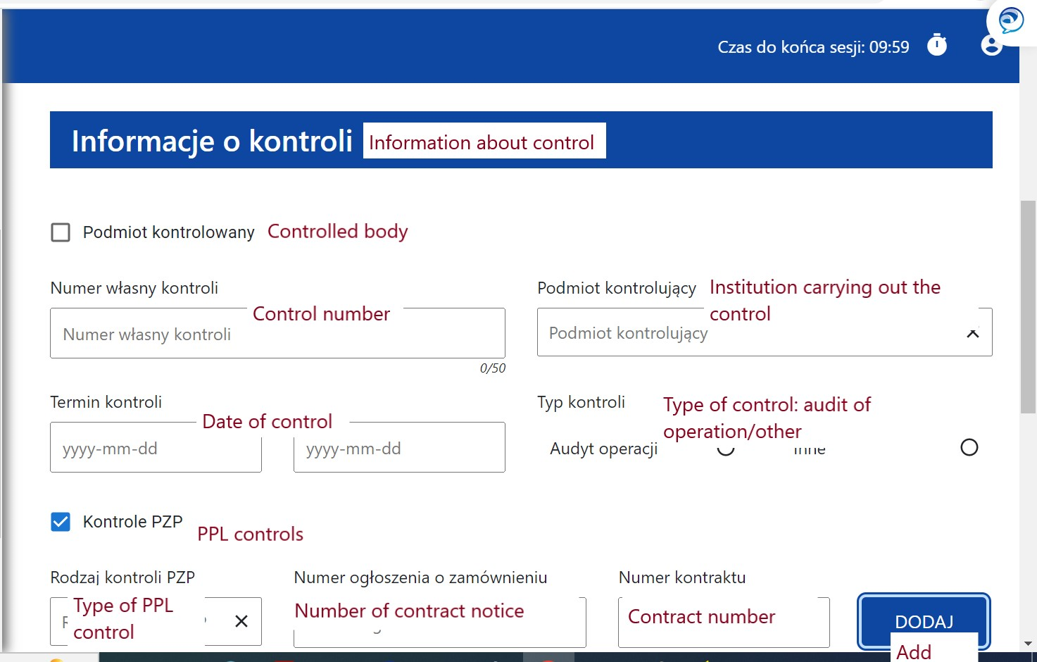
- Results of control where FLC should indicate the result and short description.
