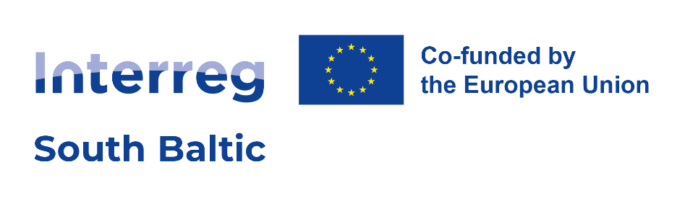


- INNOVATIVE SUSTAINABLE ATTRACTIVE ACTIVE

Interreg South Baltic Programme 2021–2027

Application for Call for external quality experts to support the assessment of the projects proposals of the Interreg South Baltic Programme 2021-2027
WWW.SOUTHBALTIC.EU

Personal data
Title (Ms./Mr.):
Name (first, last):
Date of birth:
Address:
Telephone:
Email:

Education

Please indicate your university qualifications starting from the most recent one. At least one qualification must be filled in.

Qualification 1
Title of qualification
Subject or field
Name of institution
Country
Year of graduation

Qualification 2
Title of qualification
Subject or field
Name of institution
Country
Year of graduation

Qualification 3
Title of qualification
Subject or field
Name of institution
Country
Year of graduation

Professional experience
Please indicate your relevant employment history starting from the most recent one. At least one professional experience must be filled in.

Professional experience 1
Job title
Organisation
Period:
from (mm/yy)
to (mm/yy)
Main responsibilities

Professional experience 2
Job title
Organisation
Period:
from (mm/yy)
to (mm/yy)
Main responsibilities

Professional experience 3
Job title
Organisation
Period:
from (mm/yy)
to (mm/yy)
Main responsibilities

Professional experience 4
Job title
Organisation
Period:
from (mm/yy)
to (mm/yy)
Main responsibilities

Professional experience 5
Job title
Organisation
Period:
from (mm/yy)
to (mm/yy)
Main responsibilities

Experience in the thematic fields covered by the South Baltic Programme 2021-2027
Programme Measure | Description
1.1 Digitalising the region
1.2 Building connectivity of the region through internationalization
2.1 Supporting transition towards green energy
2.2 Promoting sustainable use of water
2.3 Supporting a circular and more resource efficient development
3.1 Developing sustainable, resilient, and innovative tourism
4.1 Strengthen the cooperation capacity of actors based within the South Baltic Area (including civil society)

- Experience in the Baltic Sea region cooperation and knowledge about the regions covered by the South Baltic Programme
Type of experience | Description
Experience in the Baltic Sea region cooperation
Knowledge about the regions covered by the South Baltic Programme

- Experience in cohesion policy, European territorial cooperation and/or international cooperation
Type of experience | Description (of related tasks, activities, programmes, etc.)
Experience at project level (project preparation, implementation etc.)
Experience at programme level (programme management, strategy development etc.)
Experience in programme evaluation (including ex-ante, on-going/mid-term, ex-post evaluation)
Other

Project assessment experience

Type of programme | Description (programme, year, types of projects, number of assessed projects etc.)
Interreg South Baltic Programme 2007-2013, 2014-2020
Other Interreg (ETC) programmes
European Commission programmes (e.g. EU Framework programmes, HORIZON 2020, LIFE, IEE, etc.)
National or regional programmes/funds
Other

Language skills (English)
Please indicate your language proficiency according to the CEF - Common European Framework of Reference for Languages (from A1 to C2).

Language | Reading | Speaking | Writing
English

Confirmation
“I agree for my personal data, contained in this application, to be processed in order to establish a pool of external assessors under the Interreg South Baltic Programme 2021-2027, in accordance with the Regulation (EU) 2016/679 of the European Parliament and of the Council of 27 April 2016 on the protection of natural persons with regard to the processing of personal data and on the free movement of such data, and repealing Directive 95/46/EC (General Data Protection Regulation, GDPR) (OJ L 119, 4.5.2016, pp. 1–88).”.
Place and date | Signature

Further information on the personal data protection
According to the Regulation (EU) 2016/679 of the European Parliament and of the Council of 27 April 2016 on the protection of natural persons with regard to the processing of personal data and on the free movement of such data, and repealing Directive 95/46/EC (General Data Protection Regulation, GDPR) (OJ L 119, 4.5.2016, pp. 1–88):
The main purpose of the personal data collection is the establishment of a pool of external assessors under the Interreg South Baltic Programme 2021-2027;
- The appropriate Administrators of your personal data are:
1. The Director of the Center for European Projects (CPE), to the extent that it acts as the Joint Secretariat for the Interreg South Baltic Programme 2021-2027, with headquarters at ul. Puławska 180, 02-670 Warszawa;
2. The Minister of Funds and Regional Policy, to the extent to which it performs the tasks of the Member State and performs the functions of the Managing Authority (MA) for the Interreg South Baltic Programme 2021-2027, with headquarters at ul. Wspólna 2/4, 00-926 Warsaw;
3. The competent authority that has been appointed to perform the tasks of the controller.
- The expert included in the pool of external assessors has the right to cancel his/her consent to the processing of the personal data at any time. In such case administrator will immediately remove the expert form the pool.
- The expert included in the pool of external assessors has the right to amend or update his/her personal data.
- The personal data is provided by the applicant (expert) on a voluntary basis.

